Working with DotSpatial Controls

**Tutorial (1)**

Purpose of this tutorial: Become familiar with the DotSpatial map control and its following functionalities: ZoomIn, ZoomOut, Zoom to Extent, Select, Measure, Pan, Info, and load data.

**Step 1**: Download the DotSpatial class library

Download the DotSpatial class library. Next unblock and unzip the downloaded folder. Right click on the downloaded folder and choose the properties from the context menu. On the folder properties window click unblock button. After unblocking the folder and unzip it.

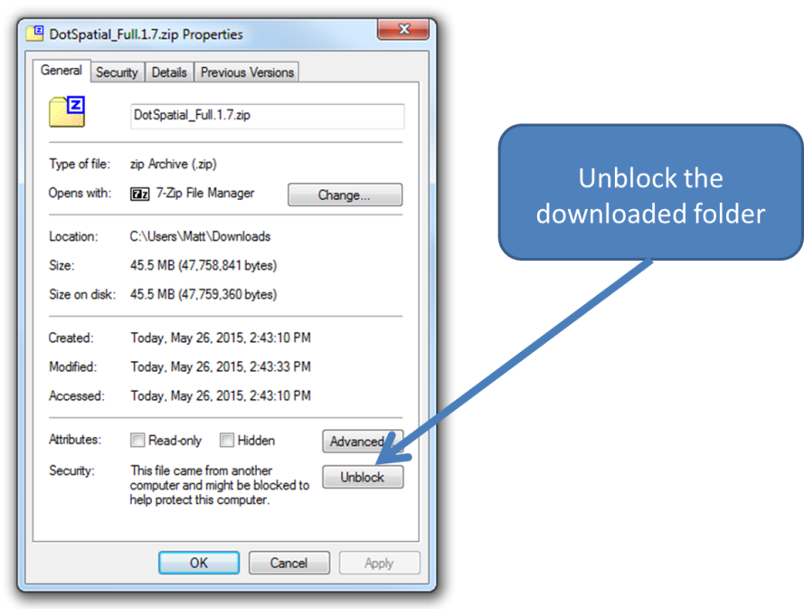

Figure 1: Properties Window

**Step 2:** Add the DotSpatial reference

Add the DotSpatial references

1. Right click on the References folder and select the add reference from the context menu.

2. Add the following references from the downloaded folder:

DotSpatial.Controls.dll, DotSpatial.Data.dll, DotSpatial.Data.Forms.dll, DotSpatial.Symbology.dll

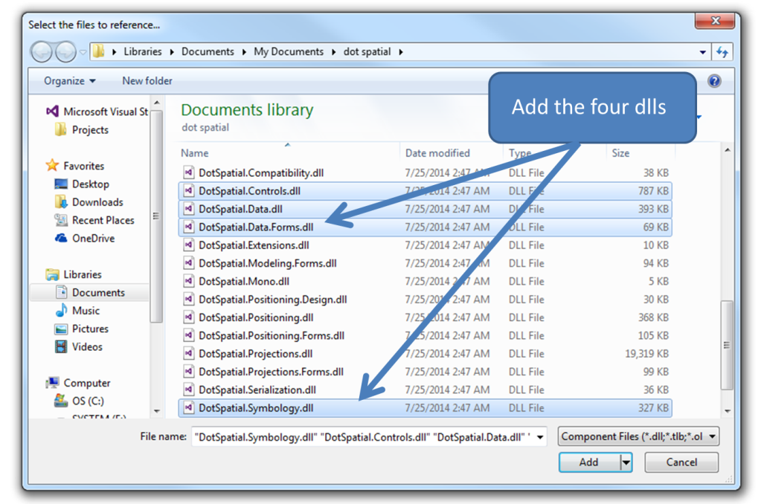

Figure 2: Required References

**Step 3:** Add the DotSpatial Controls into the Visual Studio Toolbox.

Create a new Tab on the ToolBox window and add the DotSpatial class library

Select the ToolBox on the standard menu bar. Right click on the ToolBox window and choose "Add Tab" from the context menu. Enter the new tab name as DotSpatial. On the DotSpatial tab right click and select the Choose Items from the context menu.

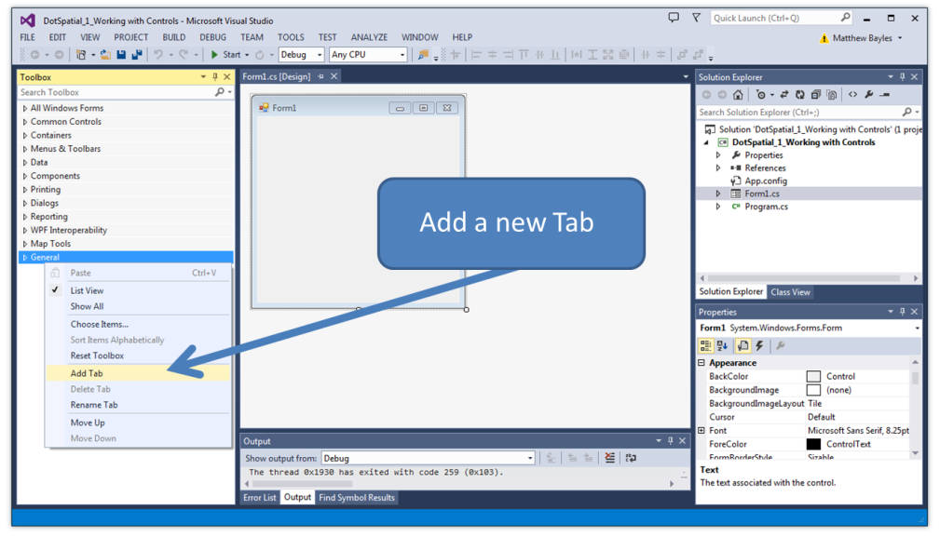

Figure 3: Adding a New Tab

Select the **DotSpatial.Controls.dll** from the downloaded folder.

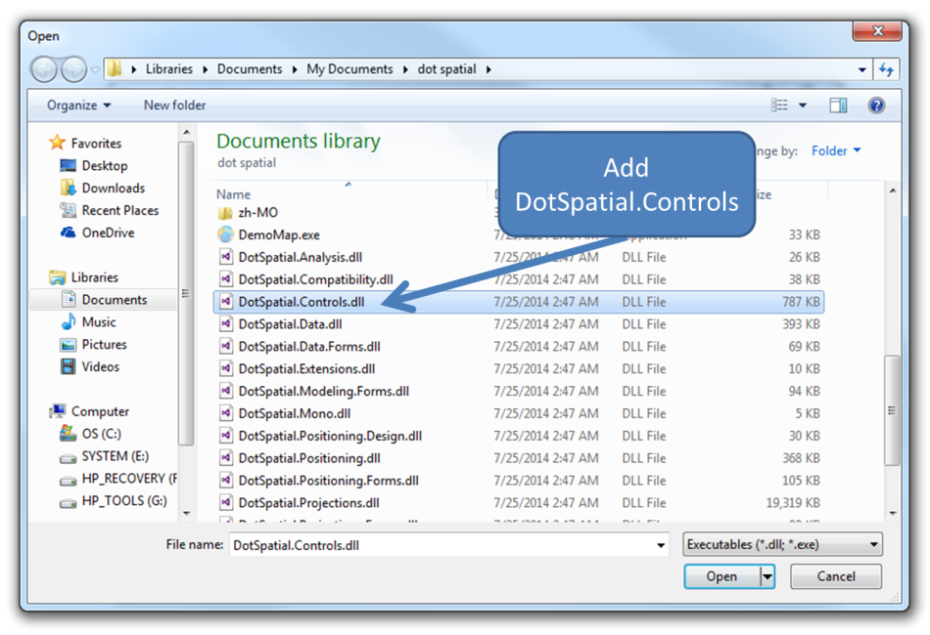

Figure 4: DotSpatial.Controls

**Step 4**: Design the GUI. (Graphical User Interface)

Design the GUI as follows:

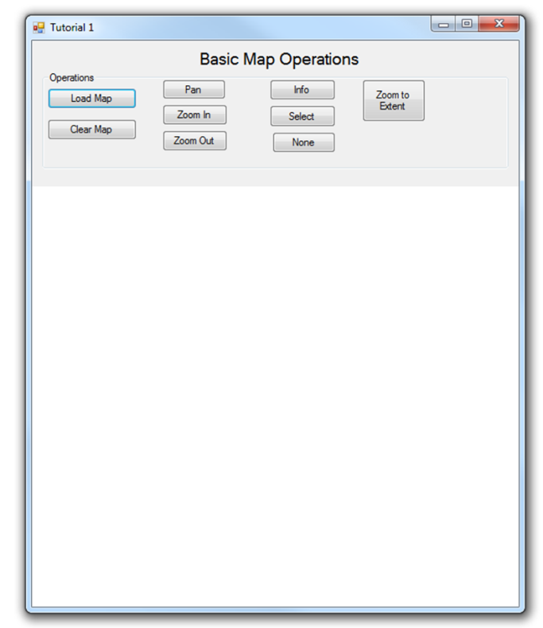

Figure 5: Final GUI

Interface design considerations.

1. Add two panel controls on the form.

Name the first panel as pnlOperations and set the dock property as **Top**.

Name the second panel as pnlMap and set the dock property as **Fill**.

2. Drag the map control on to the pnlMap from the tool box, under the DotSpatial tab. Set the dock property of map to **Fill**.

3. Add a group box on to the pnlOperations and name it as grbOperations.

4. Create ten buttons inside the group box.

Set the buttons properties as follows:

|  |  |  |
| --- | --- | --- |
| Control | Name | Text |
| Button1 | btnLoad | &Load Map |
| Button2 | btnClear | &Clear Map |
| Button3 | btnZoomIn | Zoom &In |
| Button4 | btnZoomOut | Zoom &Out |
| Button5 | btnZoomToExtend | Zoom to &Extent |
| Button6 | btnPan | &Pan |
| Button7 | btnInfo | In&fo |
| Button8 | btnSelect | &Select |
| Button9 | btnNone | &None |

Use shortcut keys for the button click event. For example the Load Map button's short cut key is Shift + L. To implement this feature, on the properties window of the button select the Text property and use the “&” sign in front of any letter. In the load button case, Text property should be “**&L**oad Map.”

5. Add a title label above the group box. The name of the label should be lblTitle and the text property of the label is Basic Map Operations.

**Step 5:** Write the code for implementing the map operations.

Add the following namespace

//Required namespace

using DotSpatial.Controls;

Double click over the button on the form to get the selected button's click event code view.

private void btnLoad_Click(object sender, EventArgs e)

{

//AddLayer method is used to add shape layers

map1.AddLayer();

}

private void btnClear_Click(object sender, EventArgs e)

{

//ClearLayers method is used to remove all the layers from the mapcontrol

map1.ClearLayers();

}

private void btnZoomIn_Click(object sender, EventArgs e)

{

//ZoomIn method is used to ZoomIn the shape file

map1.ZoomIn();

}

private void btnZoomOut_Click(object sender, EventArgs e)

{

//ZoomOut method is used to ZoomIn the shape file

map1.ZoomOut();

}

private void btnZoomToExtent_Click(object sender, EventArgs e)

{

//ZoomToMaxExtent method is used to Extent the shape file

map1.ZoomToMaxExtent();

}

private void btnPan_Click(object sender, EventArgs e)

{

//Pan function is used to pan the map

map1.FunctionMode = FunctionMode.Pan;

}

private void btnInfo_Click(object sender, EventArgs e)

{

//Info function is used to get the information of the selected shape

map1.FunctionMode = FunctionMode.Info;

}

private void btnSelect_Click(object sender, EventArgs e)

{

//Select function is used to select a shape on the shape file

map1.FunctionMode = FunctionMode.Select;

}

private void btnNone_Click(object sender, EventArgs e)

{

//None function is used to change the mouse cursor to default

map1.FunctionMode = FunctionMode.None;

}

To display the tool tip message for the buttons, add the following code in the form load event.

Double click over the form for getting the form load event code view.

private void frmTutorial1_Load(object sender, EventArgs e)

{

ToolTip btnToolTip = new ToolTip();

btnToolTip.SetToolTip(btnLoad, "Shift + L");

btnToolTip.SetToolTip(btnZoomIn, "Shift + I");

btnToolTip.SetToolTip(btnZoomOut, "Shift + O");

btnToolTip.SetToolTip(btnClear, "Shift + C");

btnToolTip.SetToolTip(btnZoomToExtent, "Shift + E");

btnToolTip.SetToolTip(btnLoad, "Shift + L");

btnToolTip.SetToolTip(btnInfo, "Shift + f");

btnToolTip.SetToolTip(btnSelect, "Shift + S");

btnToolTip.SetToolTip(btnNone, "Shift + N");

btnToolTip.SetToolTip(btnPan, "Shift + P");

}

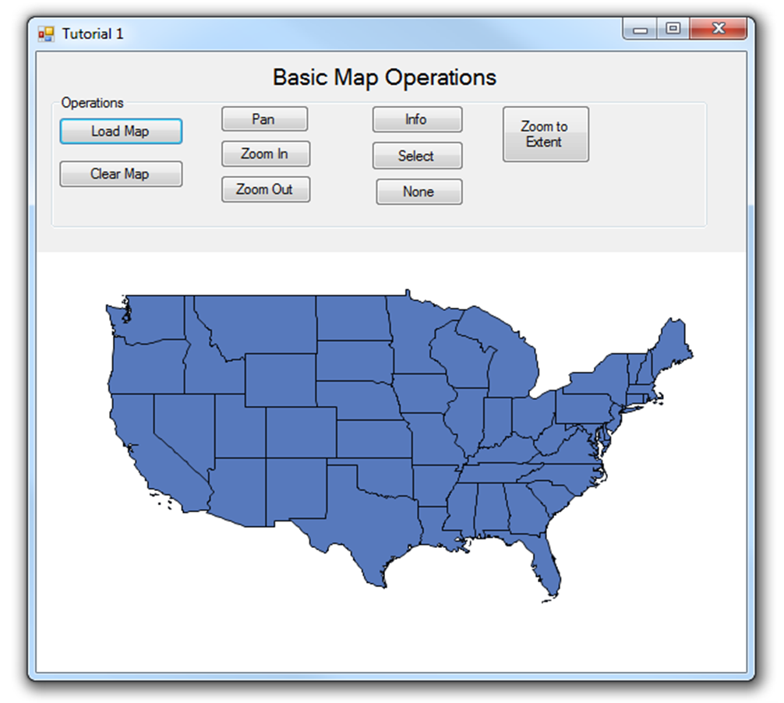

Figure 6: Project Output